DUDE Admin Guide
Version | Comment
1.0 | Initial Version

Pre-Reqs
- Run the DUDE-PreReqs.ps1 to create all necessary components needed by the DUDE. Make sure to read all the parameters.
- Open the function app in Azure, go to App Files and add “functionTimout”: “00:30:00” to the host.json and hit Save: (make sure that you format it correctly ,)
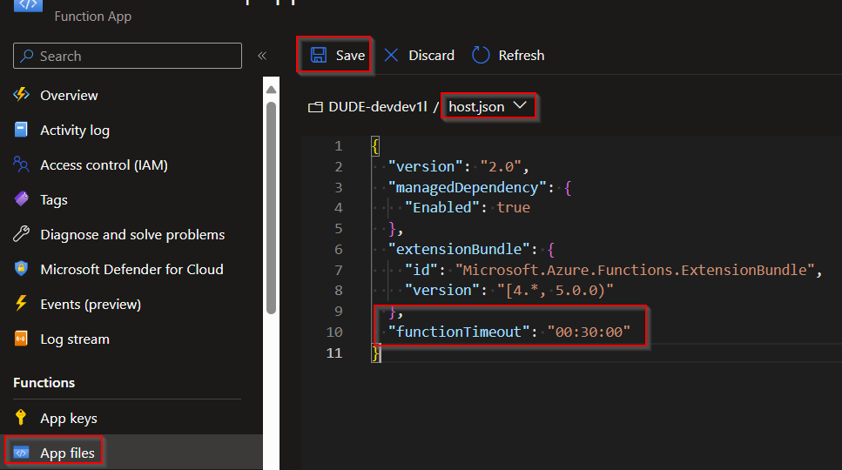
- In the profile.ps1, comment out the following lines and hit Save:
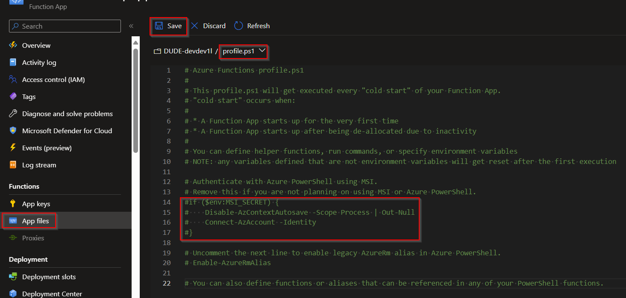
- In the requirements.psd1 add the Az and AzTable modules and hit Save:
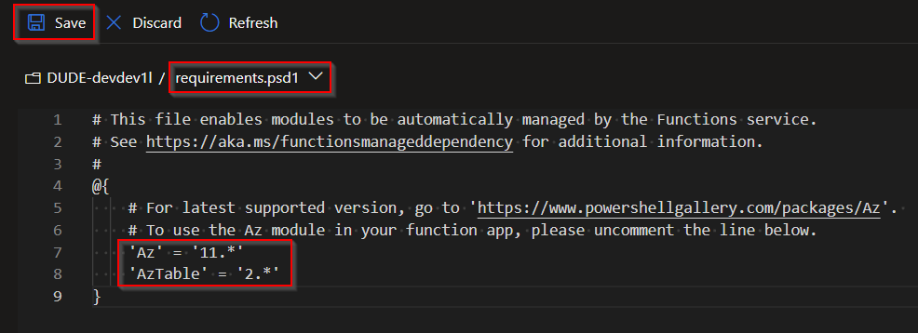

Setup
- Go to overview and select Create function:
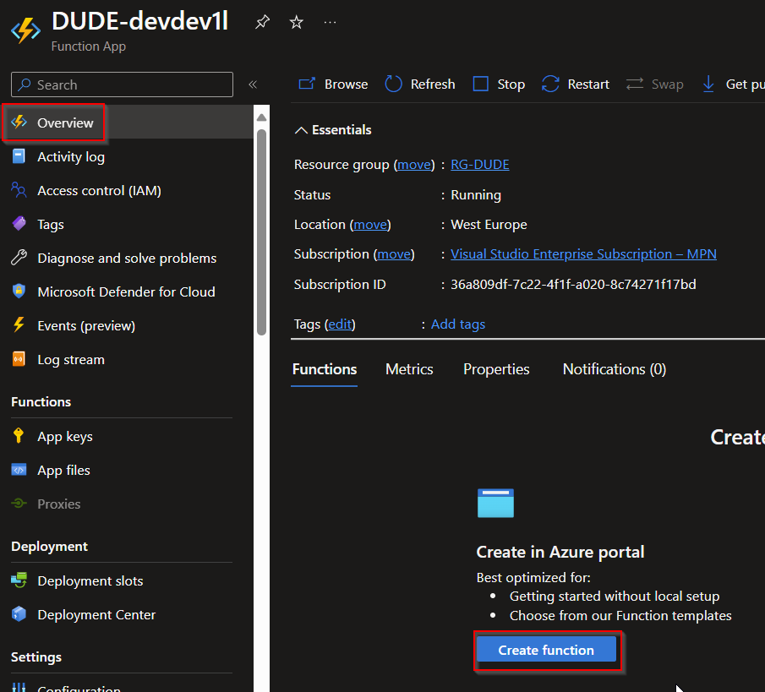

- Select Timer trigger add a function name, set a schedule and hit Save:
0 0 */2 * * * will make DUDE run every 2 hours. Use this site to create custom intervals:
https://ncrontab.swimburger.net/
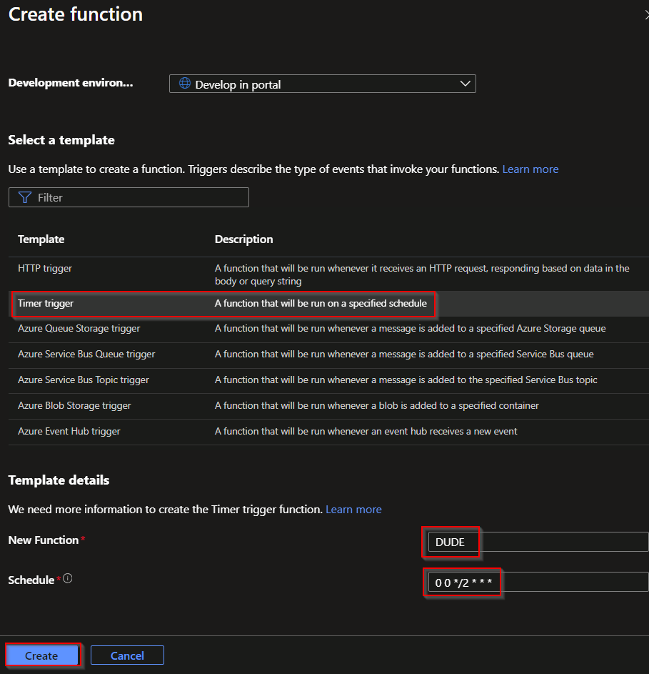
- Open Code + Test and paste the DUDE.ps1 script into the run.ps1 and hit Save:
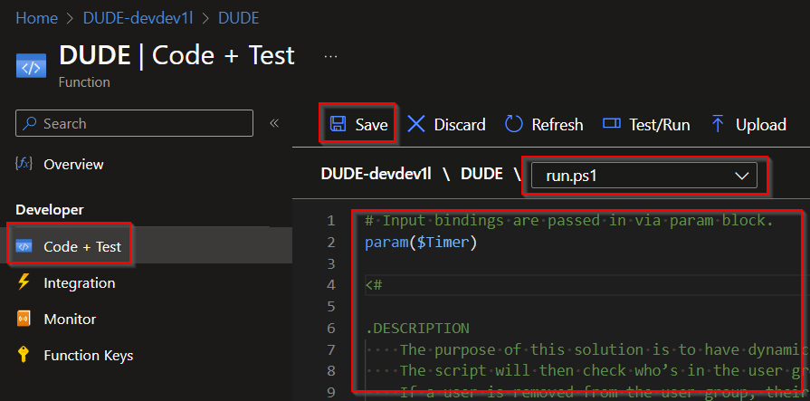
- Update the variables if needed, make sure to run in Debug mode before moving to Prod mode!!!!
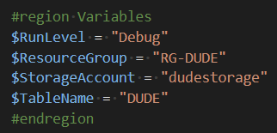

Azure Table
Use the DUDE-AddAzTableRow.ps1 to add information to your DUDE table.

